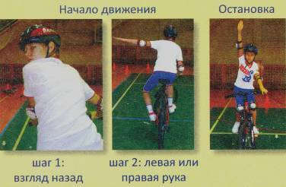

[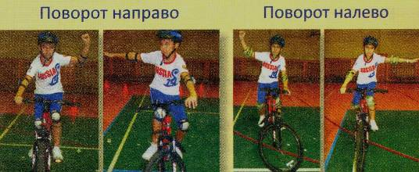](http://prosdo.ru/ouazoc/%D0%97%D0%BD%D0%B0%D1%82%D0%BE%D0%BA%D0%B8+%D0%BF%D0%B4%D0%B4+(%D0%B8%D0%BD%D0%B4%D0%B8%D0%B2%D0%B8%D0%B4%D1%83%D0%B0%D0%BB%D1%8C%D0%BD%D1%8B%D0%B9+%D0%BA%D0%BE%D0%BD%D0%BA%D1%83%D1%80%D1%81)+1+%D1%81%D1%82%D0%B0%D0%BD%D1%86%D0%B8%D1%8F+%E2%80%93+%C2%AB%D0%97%D0%BD%D0%B0%D1%82%D0%BE%D0%BA%D0%B8+%D0%9F%D1%80%D0%B0%D0%B2%D0%B8%D0%BB+%D0%B4%D0%BE%D1%80%D0%BE%D0%B6%D0%BD%D0%BE%D0%B3%D0%BE+%D0%B4%D0%B2%D0%B8%D0%B6%D0%B5%D0%BD%D0%B8%D1%8F%C2%BBc/28724_html_m235079bb.jpg)